**SKILL LEARNT: SPRING CORE AND MAVEN (WEEK 3)**

**EXERCISE 1: CONFIGURING A BASIC SPRING APPLICATION**

STEP 1: Firstly, I created a simple Maven project where Group Id is com.library and Artifact Id is LibraryManagement.

STEP 2: Next I added the spring core dependency in pom.xml. The code for pom.xml is as given in the picture

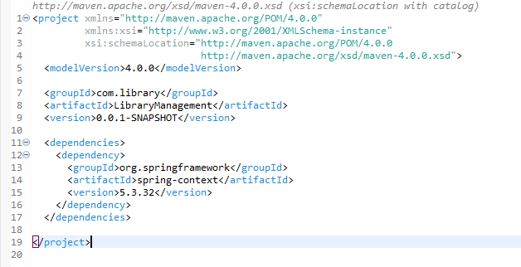

STEP 3: Next under src/main/resources I created a File named applicationContext.xml. The code for this is given below,

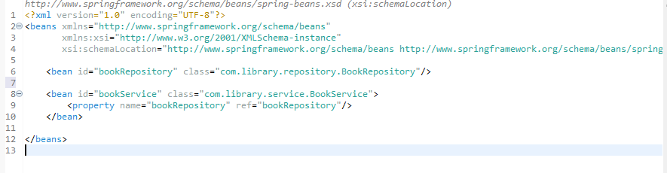

Continued image of line 4……

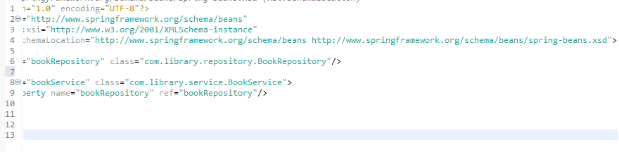

STEP 4: Under src/main/java, I created a Package named com.library.repository under which a Class named BookRepository. The code for BookRepository is given below,

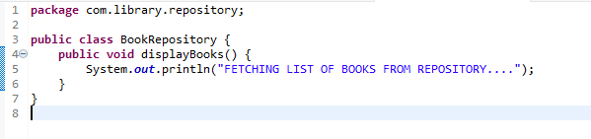

STEP 5: Under src/main/java, I created a Package named com.library.service under which a Class named BookService. The code for BookService is given below,

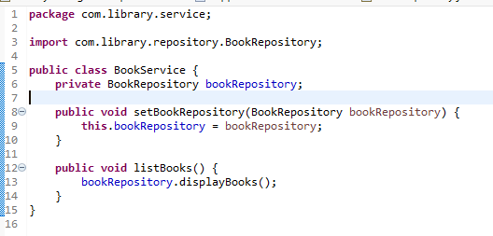

STEP 6: Under src/main/java, I created a Package named com.library1 under which a Class named MainApp. The code for MainApp is given below,

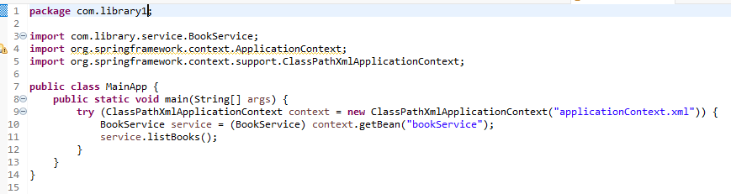

STEP 7: Running the MainApp application produces the output



**EXERCISE 2: IMPLEMENTING DEPENDENCY INJECTION**

STEP 1: Firstly, I created a simple Maven project where Group Id is com.library and Artifact Id is Library-Management.

STEP 2: Next I added the spring core dependency in pom.xml. The code for pom.xml is as given in the picture.

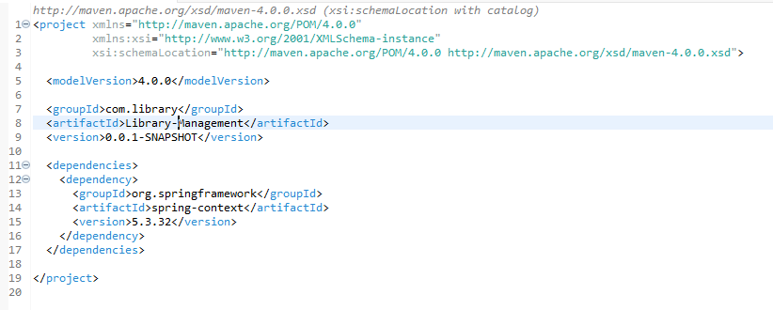

STEP 3: Next under src/main/resources I created a File named applicationContext.xml. The code for this is given below

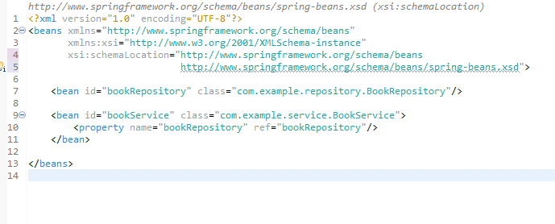

STEP 4: Under src/main/java, I created a Package named com.example.repository under which a Class named BookRepository. The code for BookRepository is given below

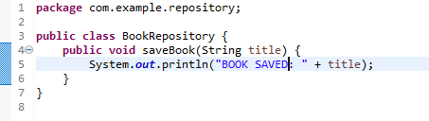

STEP 5: Under src/main/java, I created a Package named com.example.service under which a Class named BookService. The code for BookService is given below

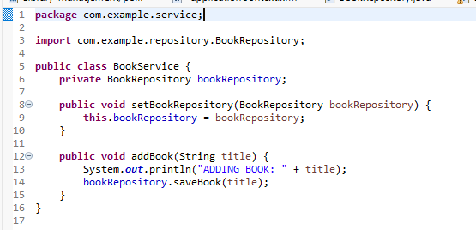

STEP 6: Under src/main/java, I created a Package named com.library1 under which a Class named LibraryManagementApplication. The code for it is given below

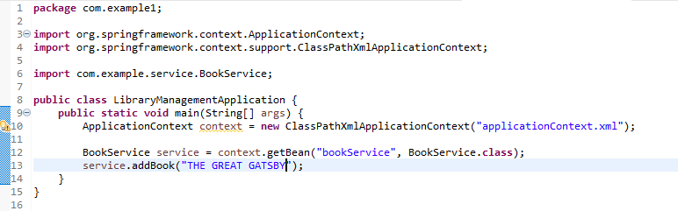

STEP 7: Running the LibraryManagementApplication application produces the output



**EXERCISE 4: CREATING AND CONFIGURING A MAVEN PROJECT**

STEP 1: Firstly, I created a simple Maven project where Group Id is com.library and Artifact Id is Library--Management.

STEP 2: Next I added spring dependency in pom.xml for Spring Context, Spring AOP, and Spring WebMVC. The code for pom.xml is as given in the picture

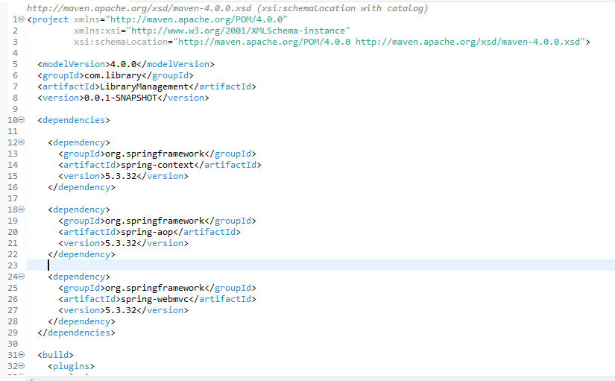

Continued…..

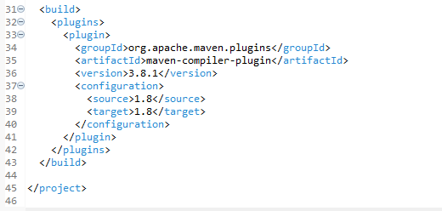

STEP 3: Next I updated the Maven Project to download all your Spring dependencies and configure the compiler plugin to use Java 1.8.



STEP 4: Next under src/main/resources I created a File named applicationContext.xml. The code for this is given below

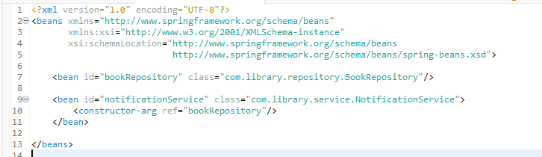

STEP 5: Under src/main/java, I created a Package named com.library.repository under which a Class named BookRepository. The code for BookRepository is given below

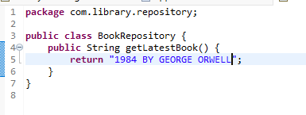

STEP 6: Under src/main/java, I created a Package named com.library.service under which a Class named NotificationService. The code for NotificationService is given below

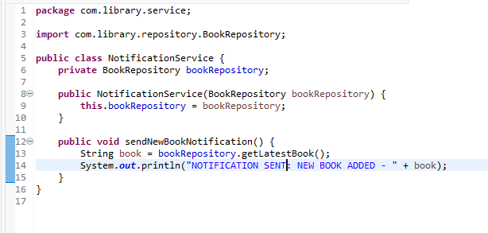

STEP 7: Under src/main/java, I created a Package named com.library under which a Class named LibraryManagementApplication. The code for LibraryManagementApplication is given below

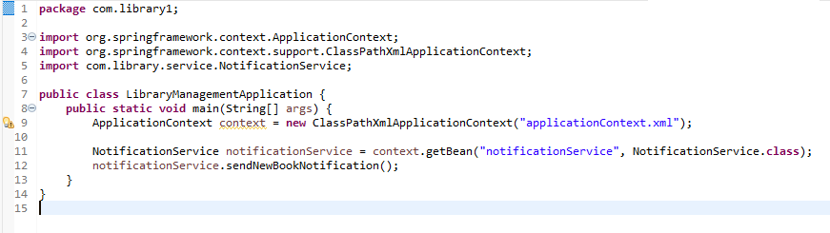

STEP 8: Running the LibraryManagementApplication application produces the output

